QUOTATION
Customer:
Attention: |  |  | Ref:
Contact No: |  |  | Date: | 7/10/2021
Item No. |  | Quantity
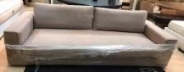 | Sofa | 7
 | Dining set 180 cm 4 chairs | 9
 | Dining set 160 cm 4 chairs | 2
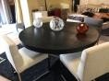 | Dining set round black 160cm 4 chairs | 1
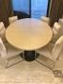 | Dining set oval 250 cm 6 chairs | 1
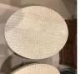 | Coffee table square | 5
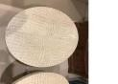 | Coffee table round 90cm | 6
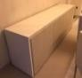 | Cabinet | 9
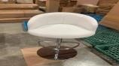 | bar stools | 21
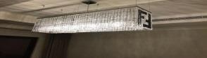 | Chandelier | 29
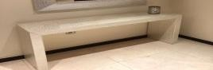 | console 140 cm | 29
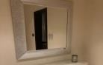 | mirror 110*110 cm | 20
 | mirror 110*75 cm | 20

 | mirror 257*75 cm | 10
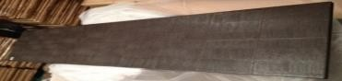 | wall panel | 12
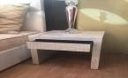 | side tables | 28
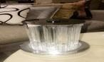 | side lamp murano round small | 22
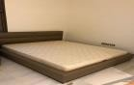 | bed peplo 185 cm | 2
 | bed diamente 185 cm | 9
 | bed urale 165 cm | 2
 | bed peplo 165 cm | 1
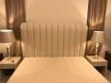 | bed alexander 200 cm | 1
 | Fabric rolls | 10

